PUZZLES OF DECOYING

1. White mates/ Black wins
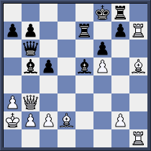

W:

B:

2. White mates/ Black wins
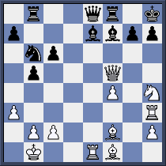

W:

B:

3. White wins/ Black mates
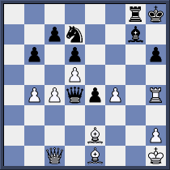

W:

B:

4. White wins/ Black to mates
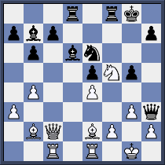

W:

B:

5. White wins/ Black wins
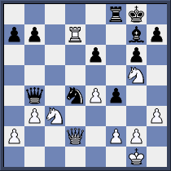

W:

B:

6. White mates/ Black mates
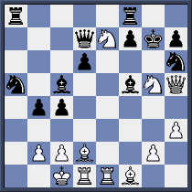

W:

B:

